Using the Logic Gate Simulator
Download Logic Gate Simulator from Blackboard or the no-install executable from the project home page: http://www.kolls.net/gatesim/
Unzip this into a folder on your home drive, and run the GatesWpf to start. Creating circuits with the simulator is quite simple:
- Add gates or other components by dragging and dropping the different components into position.
- Clicking on the output of one component allows you to draw a connection to the input of another. You can connect a single output to multiple inputs, if required.
- Input switches (boxes) can be turned on (red) and off (white) by clicking them
- The components menu fades when you move the mouse away. Click on ‘Compound Gates’ to see the full range of gates available.
- You can create your own circuits and save them as components for building larger and more complex circuits – use the ‘Create IC’ menu button (top right) to save a circuit as a single integrated circuit.

Exercise 1: NAND to AND – Build a Circuit
It is possible to use NAND or NOR gates to construct all of the other gate types. Making an AND gate using two NAND gates is very simple. Add to NAND gates, two inputs and one output to the circuit as shown:
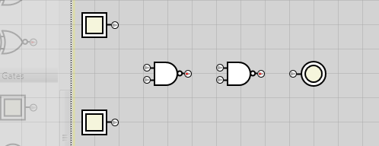
Then wire up the circuit as below:
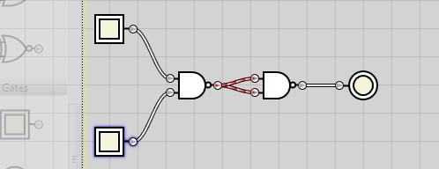
Test the circuit by switching the inputs on and off. The output should turn red only when both inputs are switched on. Note also how you can see intermediary 1s and 0s by the red and white connections in a circuit.

Exercise 2: Create and Integrated Circuit
To make it possible to build more complicated circuits, the Logic Simulator allows you to save an existing circuit as an integrated circuit (IC) and to then use this in other designs.
With the AND circuit from the previous exercise still open, delete any extra components that you may have dropped that are not part of the circuit. (Click on a component and press delete on the keyboard to remove).
Now click on the Create IC button: 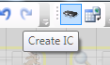
A new component will appear at the bottom of the components selection box. You can click on this to rename it. Name this component AND. You can now delete the current circuit and create a new one using your AND IC, e.g.:
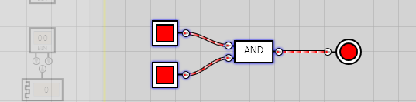
This is just a very simple example. By building larger circuits with more input and output ICs, much more complicated circuits can be simulated.

Exercise 3: Binary inputs and outputs
It is easy enough to extend this to start building circuits that act as adders (for example). But manually controlling multiple switches or having to work out from a set of indicators whether an answer is actually correct is not so simple. The Logic Simulator provides numerical input and output components to make this easier. A clock input switches automatically between 0 and 1 outputs at set time intervals – you can set how long between switching by entering the number of milliseconds.
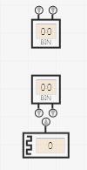 | Numeric Output. Use this to visualise multiple circuit outputs in one indicator.  Numeric Input. Use this to set multiple circuit inputs at once.  Clock. Set an alternating input.

Note that the numeric inputs and outputs have a number of display modes – and that they rotate through the different modes each time they are clicked. The modes are: BIN – binary; OCT – octal, a base-8 numerical representation, DEC – decimal, HEX – hexadecimal, D2C – Decimal, 2’s complement (-8 to +7) and BCD – Binary Coded Decimal. For this exercise, we are only interested in binary, though the other modes can be useful to testing adders and other circuits.
Place a numeric input into a new blank circuit – when prompted for how many bits, select 2. Do the same to add a numeric output. (You can rotate the components but right-clicking on them, then dragging the mouse – this can improve the visibility of the connections in your circuits). Test that this works by building a trivial circuit, e.g.:
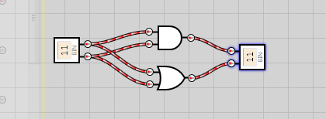

Exercise 4: Some Proper Circuits
Time to build some proper circuits!
Create and test a half-adder and a full-adder circuit – creating each as an IC. By right clicking on an IC in the component selection box, you can save the IC to disk for importing another time. The schematics below show you the circuits required for a half-adder and a full-adder.
Half-Adder: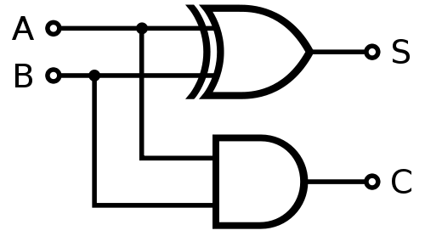 | Full-Adder: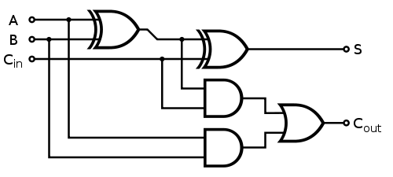

Exercise 5: A Real Work Out (Challenge Exercise)
This is a bonus challenge exercise to give you more of a mental work out. After building and testing the Full-Adder circuit, save it as an IC. Then use your one-bit Full-Adder IC as a component in building an 8-bit adder. Use two numeric input components and a single numeric output to test your 8 bit adder.
When you complete this, congratulate yourself!

